**ELEC-E7250 - Laboratory Course in Communications Engineering**

Preliminary exercises: Path loss measurements

Group members: Xingji Chen and Zheyuan Liu

1. Try to find frequency bands where following technologies operate in Finland:
2. GSM downlink and uplink frequencies and the frequency bands different operators are using.
3. W-CDMA and/or HSPA downlink and uplink frequencies and the frequency bands different operators are using.
4. LTE downlink and uplink frequencies and the frequency bands different operators are using.
5. FM-radio
6. WLAN
7. Bluetooth

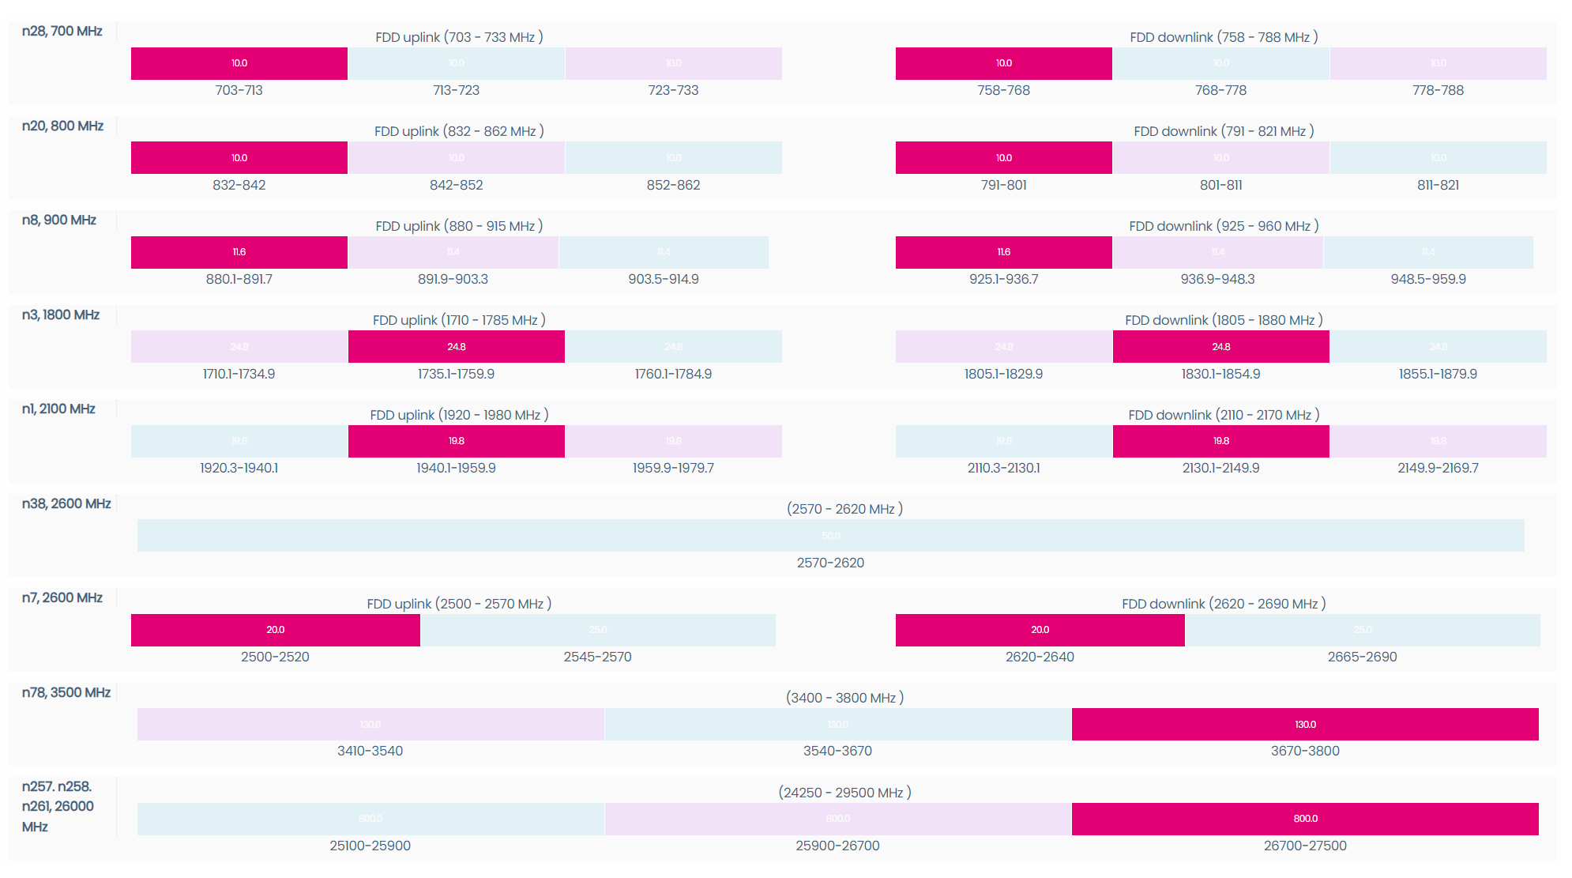

1. **GSM 900:**

Uplink frequency range is typically 880-915 MHz.

Downlink frequency range is 925-960 MHz.

**GSM 1800:**

Uplink frequency range is 1710-1785 MHz.

Downlink frequency range is 1805-1880 MHz.

|  |  |  |  |
| --- | --- | --- | --- |
|  |  | UL | DL |
| GSM | DNA Plc | 880.100 - 891.700 MHz  (Nationwide, excluding the province of Åland) | 925.100 - 936.700 MHz  (Nationwide, excluding the province of Åland) |
| Telia Finland Oyj | 891.900 - 903.300 MHz  (Nationwide, excluding the province of Åland)  885.100 - 902.300 MHz  (The province of Åland) | 936.900 - 948.300 MHz  (Nationwide, excluding the province of Åland)  930.100 - 947.300 MHz  (The province of Åland) |
| Elisa Corporation | 903.500 - 914.900 MHz  (Nationwide, excluding the province of Åland) | 948.500 - 959.900 MHz  (Nationwide, excluding the province of Åland) |
| Ålands Telekommunikation Ab | 880.100 - 884.900 MHz  (The province of Åland)  902.500 - 914.900 MHz  (The province of Åland) | 925.100 - 929.900 MHz  (The province of Åland)  947.500 - 959.900 MHz  (The province of Åland) |

1. **2100 MHz Band:** This is the most commonly used band for W-CDMA/HSPA networks worldwide.

Uplink frequency typically ranges from 1920 to 1980 MHz.

Downlink frequency typically ranges from 2110 to 2170 MHz.

**900 MHz Band** (also known as UMTS900):

Uplink frequency typically ranges from 880 to 915 MHz.

Downlink frequency typically ranges from 925 to 960 MHz.

**Other Bands:**

W-CDMA and HSPA networks can also operate in other frequency bands such as 850 MHz, 1900 MHz, and others, with uplink and downlink frequencies set according to the band's specification.

|  |  |  |  |
| --- | --- | --- | --- |
|  |  | UL | DL |
| W-CDMA and/or HSPA | DNA Plc | 880.100 - 891.700 MHz  (Nationwide, excluding the province of Åland)  1940.100 - 1959.900 MHz  (Nationwide, excluding the province of Åland) | 925.100 - 936.700 MHz  (Nationwide, excluding the province of Åland)  2130.100 - 2149.900 MHz  (Nationwide, excluding the province of Åland) |
| Telia Finland Oyj | 891.900 - 903.300 MHz  (Nationwide, excluding the province of Åland)  885.100 - 902.300 MHz  (The province of Åland)  1959.900 - 1979.700 MHz  (Nationwide, excluding the province of Åland)  1959.900 - 1979.700 MHz  (The province of Åland) | 936.900 - 948.300 MHz  (Nationwide, excluding the province of Åland)  930.100 - 947.300 MHz  (The province of Åland)  2149.900 - 2169.700 MHz  (Nationwide, excluding the province of Åland)  2149.900 - 2169.700 MHz  (The province of Åland) |
| Elisa Corporation | 903.500 - 914.900 MHz  (Nationwide, excluding the province of Åland)  1920.300 - 1940.100 MHz  (Nationwide, excluding the province of Åland) | 948.500 - 959.900 MHz  (Nationwide, excluding the province of Åland)  2110.300 - 2130.100 MHz  (Nationwide, excluding the province of Åland) |
| Ålands Telekommunikation Ab | 880.100 - 884.900 MHz  (The province of Åland)  902.500 - 914.900 MHz  (The province of Åland)  1920.300 - 1940.100 MHz  (The province of Åland) | 925.100 - 929.900 MHz  (The province of Åland)  947.500 - 959.900 MHz  (The province of Åland)  2110.300 - 2130.100 MHz  (The province of Åland) |

1. **800 MHz Band (Band 20):**

Uplink frequencies range from 832 MHz to 862 MHz.

Downlink frequencies range from 791 MHz to 821 MHz.

**900 MHz Band (Band 8):**

Uplink frequencies range from 880 MHz to 915 MHz.

Downlink frequencies range from 925 MHz to 960 MHz.

**1800 MHz Band (Band 3):**

Uplink frequencies range from 1710 MHz to 1785 MHz.

Downlink frequencies range from 1805 MHz to 1880 MHz.

**2100 MHz Band (Band 1):**

Uplink frequencies range from 1920 MHz to 1980 MHz.

Downlink frequencies range from 2110 MHz to 2170 MHz.

**2600 MHz Band (Bands 7 and 38):**

For Band 7 (FDD), uplink frequencies range from 2500 MHz to 2570 MHz and downlink frequencies range from 2620 MHz to 2690 MHz.

Band 38 (TDD) operates around 2570-2620 MHz.

**3500 MHz Band (Band 78):**

This band is typically used for TDD LTE and covers a range of 3400 MHz to 3800 MHz.

1. The FM radio frequencies generally range from 87.5 MHz to 108 MHz. This band is used worldwide for FM broadcasting, and the center frequencies of FM channels are typically spaced in increments of 200 kHz.
2. WLAN in Finland primarily uses the 2.4 GHz and 5 GHz frequency bands. The 2.4 GHz band includes channels spaced 5 MHz apart, with channel bandwidths ranging from 16.25 to 22 MHz. The 5 GHz band offers broader bandwidth, accommodating larger channels up to 80 MHz for faster data speeds.
3. Bluetooth typically operates in the 2.4 GHz ISM (Industrial, Scientific, and Medical) band. This band is a globally available frequency range, divided into 79 channels each 1 MHz wide.
4. How much 1 W (Watt) is on dBm scale. How much -40dBm is in Watts? Show the equations.





1. What are the bandwidths of the described technologies and what is the shape of their spectrum. Explain briefly the shape and bandwidth of the spectrum. In addition to the bandwidth measurement on the laboratory exercise, the signal powers are measured. What kind of power levels (in dBm scale) you expect to find in the exercise?
2. GSM: The bandwidth of each GSM channel is typically 200 kHz. The spectrum exhibits a comb-like structure due to the TDMA nature of GSM, with each peak representing a different time slot within a TDMA frame.
3. W-CDMA/HSPA: These technologies use wider channels compared to GSM, typically 5 MHz for W-CDMA. The spectrum has a more continuous shape due to the CDMA technology which spreads the signal over the entire bandwidth.
4. LTE: LTE supports various bandwidths ranging from 1.4 MHz to 20 MHz. The spectrum shape is determined by OFDM technology, characterized by a main lobe and side lobes in the frequency domain.
5. FM Radio: FM radio channels are typically 200 kHz wide. The spectrum of an FM signal is characterized by its frequency modulation, with the bandwidth determined by the frequency deviation of the audio signal.
6. WLAN (Wi-Fi): Wi-Fi in the 2.4 GHz band uses channels 20 MHz wide, while the 5 GHz band can use channels up to 80 MHz wide. The spectrum shape is influenced by the OFDM technology used.
7. Bluetooth: Operates in the 2.4 GHz band with channels 1 MHz wide. The spectrum is characterized by frequency hopping spread spectrum technology, which rapidly switches frequencies within its bandwidth.

GSM/W-CDMA/LTE: Power levels from base stations could be high (e.g., up to 20-40 dBm), while mobile devices typically transmit at lower power (e.g., 0 to 23 dBm).

FM Radio: Transmission power levels can be very high for broadcast stations but are usually lower for receivers.

WLAN/Bluetooth: Power levels are generally lower, typically around 0 to 20 dBm for transmission.

1. At the laboratory exercise you will measure the path loss of 2.4 GHz and 5.8 GHz signal when a cart is moving on the hallway according to the figure below. Use ITU indoor propagation model to compute path loss along the 10 meter distance in the hallway. Ignore loss from wall penetration.

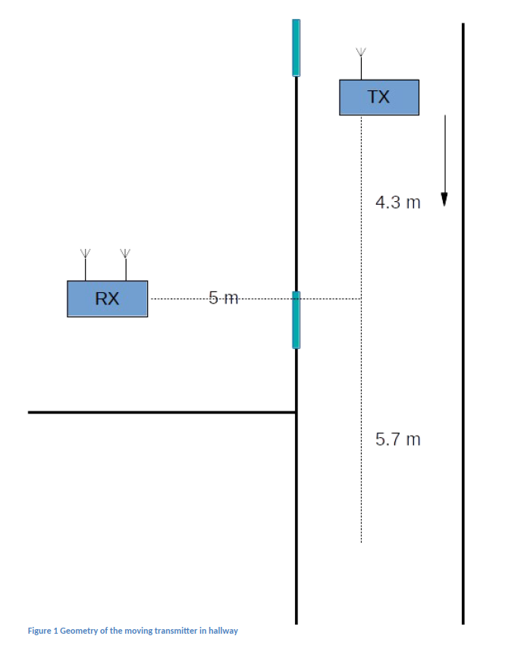



1. Plot the indoor path loss curves with link budget calculation for both frequencies. For the 2.4 GHz gains + losses are 10 dB including antenna gains, cable and connector losses etc. For the 5.8 GHz the gains + losses is approximately 0 dB. The transmission power is 10 dBm.







1. What kind of path loss curve you expect to see in the laboratory exercise when the scenario is in real life?

When the distance moved is between 0 to 4.3 meters, the path loss gradually decreases as the distance between the transmitter (TX) and receiver (RX) diminishes. When the distance moved is greater than 4.3 meters, the distance between TX and RX gradually increases, leading to an increase in path loss as well. Therefore, the expected path loss curve should be one with a trough.

1. Explain receive diversity concept and why it improves the link performance on fast fading channel?

Receive diversity combats the effects of rapid fading by using multiple antennas to receive signals through different paths. The receiver combines these various signal versions to improve overall signal quality, leading to higher reliability, reduced error rates, and better data throughput, as it's less likely for all signal paths to experience deep fades at the same time.